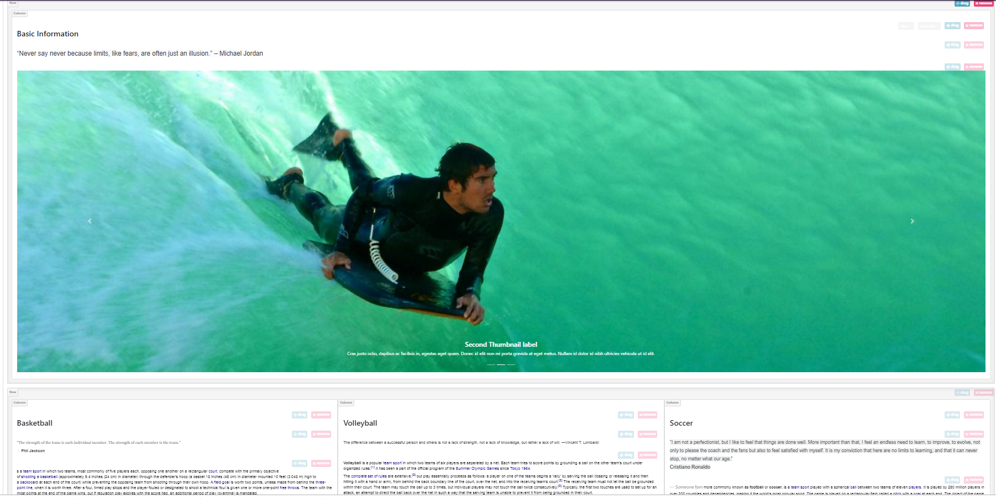

So I design this website for sporty people or who was in sports. This sports information is to help user to know what was the basic background of that sport that were they into and I insert some inspirational quotes in order them to motivate and inspired. This website could help kids who was in the wrong path of life.